**UNIVERSITY ADMIT ELIGIBILITY PREDICTOR TEAM ID: PNT2022TMID50401**

# Prior Knowledge :

**Prior knowledge** is the information and educational context a learner already has before they learn new information. A learner’s understanding of educational material can be improved by taking advantage of their prior knowledge before dealing with the new material.

General understanding about the way students learn states that the success of learning is determined by how much the learner already knows about a given topic or related topics.

**Prior knowledge** refers to the information, no matter how limited, a learner has at the start of learning a new topic. This knowledge will likely have been gathered over time in a variety of ways. If the prior knowledge is correct and consistent with the new information being taught, the effect on learning is positive. However, if prior knowledge conflicts with new information, the effect on new learning can be negative

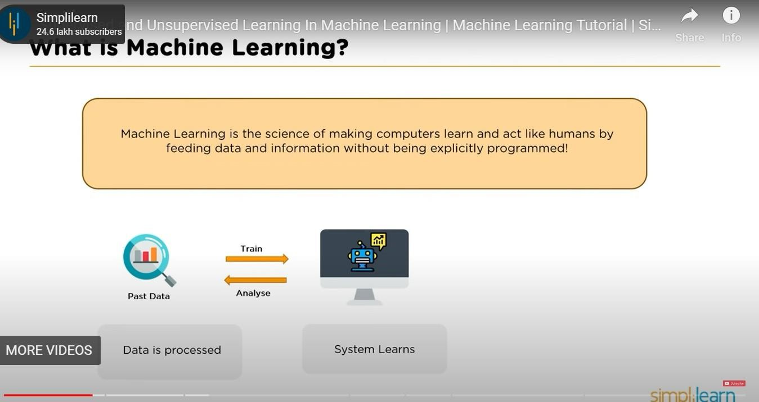

## Supervised and unsupervised learning:

### In Supervised Learning, a machine is trained using ‘labeled’ data. Datasets are said to be labeled when they contain both input and output parameters. In other words, the data has already been tagged with the correct answer.

So, the technique mimics a classroom environment where a student learns in the presence of a supervisor or teacher. On the other hand, unsupervised learning algorithms let the models discover information and learn on their own.

### Supervised machine learning is immensely helpful in solving real-world computational problems. The algorithm predicts outcomes for unforeseen data by learning from labeled training

data. Therefore, it takes highly-skilled data scientists to build and deploy such models. Over time, data scientists also use their technical expertise to rebuild the models to maintain the integrity of the insights given.

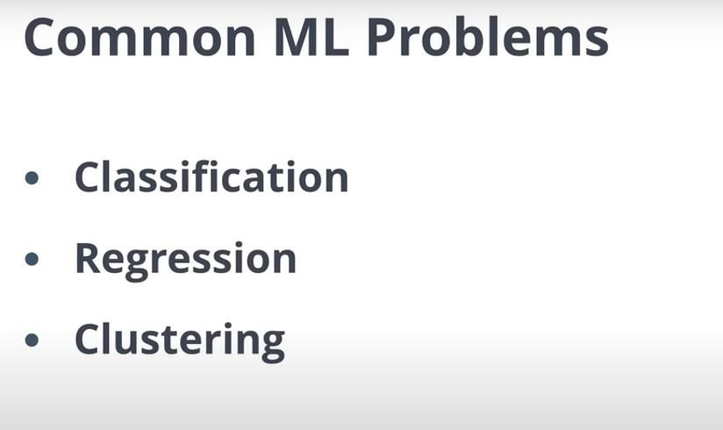

### Unsupervised learning, also known uses machine learning algorithms to analyze and cluster unlabeled datasets. These algorithms discover hidden patterns or data groupings without the need for human intervention. Its ability to discover similarities and differences in information make it the ideal solution for exploratory data analysis, cross-selling strategies, customer segmentation, and image recognition.

**Clustering, Classification and Regression :**

In the field of machine learning we all know the type of problems are different, sometimes we predict the value on previous set of data – Where data learn from available dataset, Or sometimes grouping them into some cluster. So today we are going to see what these terms are – **Clustering, Classification and Regression** means in Data science field. let’s dive into this concept.

Generally machine learning algorithms are categorised on the basis of output type and type of problem that need to be addressed. So these algorithm are divided into three categories –

1. Classification
2. Regression
3. Clustering

#### Classification : –

Classification is the type of supervised machine learning, For any given input, the classification algorithm help in the prediction of the class of the output variables. there can be multiple type of classification are – binary classification, multi-class classification.

#### Types of classification –

* K – Nearest Neighbour
* Logistic regression
* Decision tree
* Random forest
* Naive Bayes
* SVM (Support vector machine)

**Regression** : –

Regression is the type of supervised machine learning, When the output is continuous like age, height etc. one of very popular regression algorithm is **Linear Regression.**

#### Types of Regression –

* Linear Regression
* Ridge Regression
* Lasso

**Clustering** : – Clustering is unsupervised machine learning algorithm, it is used to group data point having similar characteristics as cluster.

Clustering is divided into two groups

1. Hard clustering – In hard clustering, the data point is assigned to one of the clusters only.
2. Soft clustering – It provides a probability likelihood of a data point to be in each of the clusters.

## Python Flask :

Flask Tutorial provides the basic and advanced concepts of the Python Flask framework. Our Flask tutorial is designed for beginners and professionals.

Flask is a web framework that provides libraries to build lightweight web applications in python. It is developed by **Armin Ronacher** who leads an international group of python enthusiasts (POCCO).

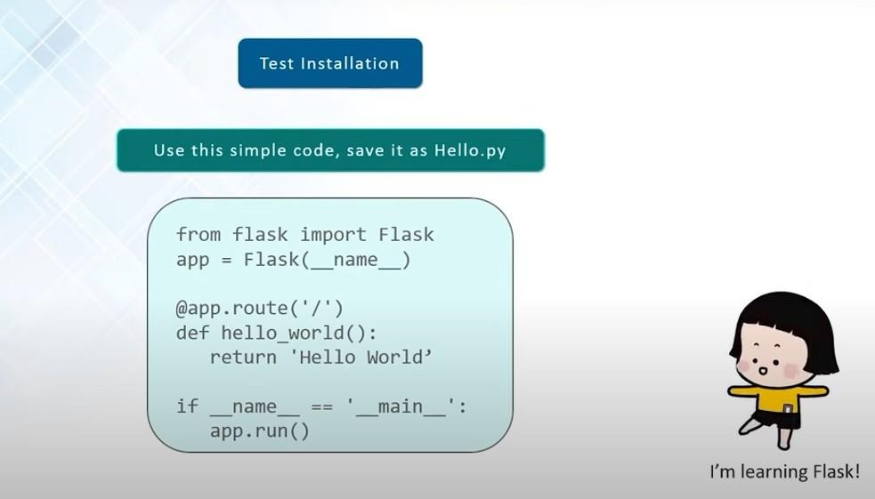

# What is Flask?

Flask is a web framework that provides libraries to build lightweight web applications in python. It is developed by **Armin Ronacher** who leads an international group of python enthusiasts (POCCO). It is based on WSGI toolkit and jinja2 template engine. Flask is considered as a micro framework.